

COMMUNITY COLLEGE OF CITY UNIVERSITY

DIVISION OF APPLIED SCIENCE AND TECHNOLOGY

AST20613 Computer System Development

2014-2015

G.V. Calendar

(Google Voice Calendar)

SYSTEM SPECIFICATION

by

Group:ISD02

WONG, Ho Long(53587834)*

LI, Sing Lun (53612386)

CHAN, Kin Chung(53612480)

SIN, Sin Chung(53587350)

WONG, Chun Kit(53581516)

Supervised by

Dr. Timothy Kwong

# **ACKNOWLEDGEMENTS**

We have taken efforts in this project, it would not have been possible without the kind help and support of many individuals and organizations. We would like to take this chance to extend our sincere thanks of all of them.

We are very thankful to our supervisor, Dr.Timothy Kwong, the guide of the project that helps us to solve many problems throughout the project. Also, we are highly indebted for his guidance and constant supervision as well as for providing necessary information regarding the project and also for his support in completing the project. Moreover, his kind concern provides much power to our team to finish the project successfully.

We would also like to express our special gratitude and thanks to the teachers who have taught us in these two years. The knowledge they have taught us is very useful in this project and it helps to fix lots of issues.

The teachers that we owe a great many thanks are: (Names are listed in alphabetical order)

Dr. Desmond Tsoi

Mr. Frank Lau

Mr. Jackie Kwong

Dr. Kenny Ma

Dr. Timothy Kwong

We would also like to thank you all of our groupmates, with all the help and support for doing the development of the project.

Thank you.

Yours sincerely,

Wong Ho Long, Li Sing Lun, Chan Kin Chung, Sin Sin Chung, Wong Chun Kit

FYP ISD-02 G.V. Calendar

**Table of Contents**

**Acknowledgements**

**Abstract**

**1. INTRODUCTION**

* 1. BACKGROUND
  2. PROJECT OVERVIEW

1.3 OBJECTIVE

1.4 PROJECT SCOPE

**2. SYSTEM REQURIREMENTS**

2.1 FUNCTIONAL AND DATA REQUIREMENTS

2.2 DATA FLOW MODEL

2.3 DATA ELEMENTS

2.4 DATA STORE

2.5 PROCESS DESCRIPTION

2.6 EXTERNAL ENTITIES DESCRIPTION

**3. DATABASE DESIGN**

3.1 DATA ANALYSIS

3.2 TABLE DEFINITION AND DESCRIPTION

3.3 DATA DESCRIPTION

3.4 OVERALL ATTRIBUTES OF Google Voice Calendar

**4. SYSTEM DESIGN**

4.1 CALENDAR

4.2 CREATE EVENT

4.3 CREATE DETAILS OF EVENT

4.4 DAY SCHEDULE

4.5 MONTH SCHEDULE

**5. TEST PLAN**

5.1 OBJECTIVE

5.2 TESTING PLAN

5.3 TESTING SCOPE

5.4 TESTING STRATEGY

5.5 MODULE-BASED TESTING

5.6 CASE-BASED TESTING

5.7 PASS OR FAIL CRITERIA

5.8 SUSPENSION CRITERIA

5.9 TESTING SCHEDULE

**6. LIMITATIONS & FURTHER DEVELOPMENTABSTRACT**

The population of portable device is growing gradually especially throughout these year, portable device may become replaced position of Computer or laptops, Not only the student studied in IT field, but also other streams of students usually use portable device in their daily life. Therefore our aim of our project is developing tools for useful managing their life by portable device friendly. Perhaps our project will try to use CSS3 and HTML5 for designing the layout of website, CSS3 and HTML5 are the too use for development.

These tools most update function included flexible property and also animation function, slider function etc, with database application for development such as MySQL. Our group is confident that our development tools will cater all requirements of portable device users indeed.

By ISD02 in 2014-2015

**1.1. Background**

Nowadays, we can see lots of Hong Kong people using their smart devices such as smart phones, tablets at any time. With the great popularity of smart products, those devices have become part of their live and they cannot live without it. The aim of those smart products is to facilitate people live and make their life become convenient. People can finish their jobs or obtain the specific information easily in a short period of time by using those smart devices and so the number of people using smart products is increasing sharply in recent years.

Besides, why those smart devices can improve people’s life or get the job done easily? First of all, smart devices are portable. People can bring it outside and use it in any places with a light afford, they can put it in their bags or just take it by hand. With the compare of traditional desktop computer or notebook, smart devices are smaller in size and lighter in weight. Also, the design of smart devices fits human’s hand so people can hold it easily and use it for a long time. Secondly, with the aid of physical size of portable devices, people can obtain information or complete a specific job easily at outdoor. For example, people can search the nearby restaurants, the review of the restaurants, the address of shops or sending emails at anywhere by using smart devices. People can obtain what they want in a simple gesture of finger. Thirdly, the functions provided by apps in smart devices can bring a bunch of useful tools that can get the job done easily. Usually, people can use web browser to do specific task and search the things they want by different webpages.

However, although there is a lot of webpages about calendar to help them to notify them what they need to do on that day, they always need to input the details of an incident by their hands. All calendars do not provide a voice input for users to input the details and voice output for users to listen the reminder of that day from the smart devices. It is difficult for those visually impaired people to use those calendars. With the issue mentioned above, we would like to complete some of the functions missed in a specific webpage to make the calendar more perfect. The details of the project will be discussed in the later section.

**1.2 Project Overview**

Voice Calendar consists of two parts which are webpage side and server side. The brief descriptions of the functions of two parts are listed follow.

**1.3 Objective**

In general, we would like to focus on making a webpage called Google Voice Calendar. The project would introduce Voice Recognition engine to obtain users’ input and output the information from the calendar. We hope our target users can use Google Voice Calendar to help them provide reminder to remember the things by using voice input and output.

In general, this project has five objectives and they are listed below.

1. Solving the problems that people will face in specific situations such as in a crowded MTR or other transportations, driving, those people who do not want to use their eyes to see the monitor of the devices.
2. To facilitate the use for blind people.
3. To provide a better function based on Google calendar
4. A more user-friendly and configurable UI should be used.

We have seen that the calendar provided by Google cannot satisfy some of the needs of users in daily life. In general, we see that people will face the problems on viewing the calendar when their hands are not “free”. The Voice Recognition engine can enhance the situation they meet. Also, the system can provide a more convenient way to check the schedule on users’ calendar. In the side of UI design, we should provide more settings to users to configure the application and make it more user-friendly.

# **1.4 SCOPE**

As we all know, people use the Google Calendar frequently but they need to use their eyes and hands to control it. They cannot use Google Calendar when they are doing others things. It causes inconvenience. For example, people cannot view their calendar during driving or working at the same time.

In order to make the Google Calendar to be more convenient and cater to universal usability, the following listed out some of the features that we aim to include in GV Calendar to solve the problems and inconvenience that those target users encounter.

**Remark: These are only the short-listed function description and introduction of function, the detailed function had illustrated in later pages. (Section 2)**

**1. Voice output system**

Using voice commands to input event in users’ schedule, for cater to users with color blindness and the users who are busy.

**2. Highlight for what had read aloud**

The users easily frustrated that when the AI had read aloud, there had no indication for users what had read aloud, the users would failed for listening some main point due to various of reasons, it is compulsory for users for check for what had said.

**3. Skipped Option for listening tapes**

The skipped option is likely to use that the listening tap is quite long for all users to listening whole times, difference from reading that could directly focus on the specific point immediately. Therefore, skipped option is a technique for user chosen the timeslot that they like to listen.

**4. Refresh function for users’ timetables**

Low memory and low ability of phone, users may usually got lost for the information that not update. Therefore refresh function had helped the information updated eventually and prevent version compulsion

**5. Setting the pointer for guidance the users views**

The users usually lost in touch while seen large amounts and array of datum, therefore a pointer may set for pointing the things that user browsing on and clarify the view of users.

**4. System Design**

**4.1 Calendar**

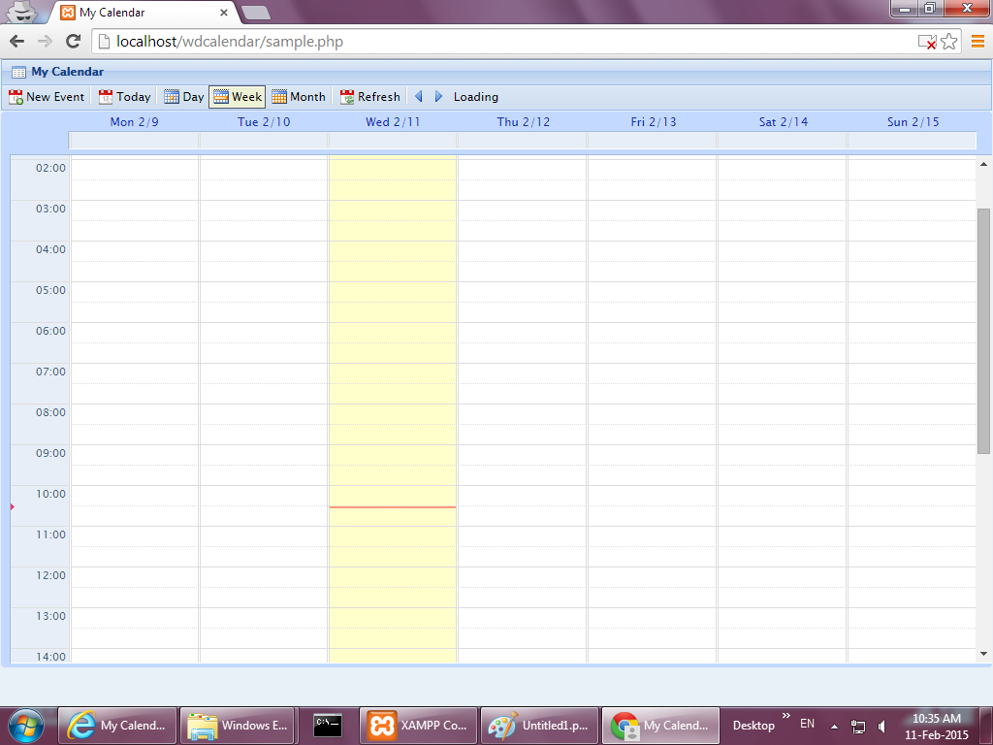

6

5

4

3

2

7

1

Figure 4.1 The page of the calendar

|  |  |  |  |
| --- | --- | --- | --- |
| 1 | New Event | Button | User can create event |
| 2 | Today | Button | User can show today time slot |
| 3 | Day | Button | User can show the chosen day time slot |
| 4 | Week | Button | User can show the weekly time slot |
| 5 | Month | Button | User can show the monthly timetable |
| 6 | Refresh | Button | User can update the information of the calendar |
| 7 | Time Slot | Box | User can create event by clicking exactly time slot |

**4.2 Create event**

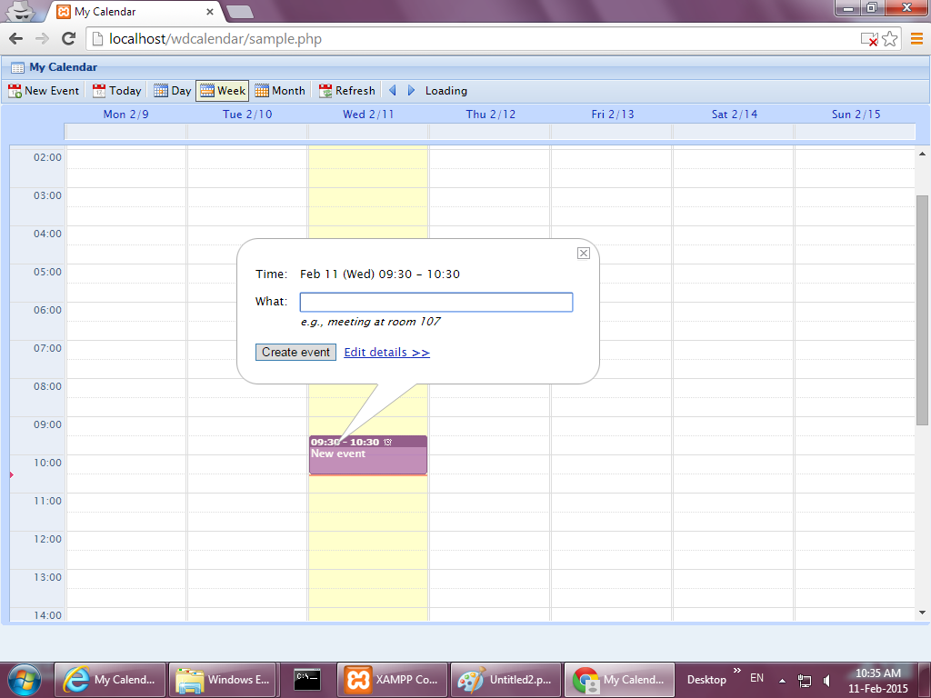

1

Figure 4.2 Create an event by clicking time slot

Notation: After clicking the exactly time slot from the calendar, users will be directed to this page to create the title of the event.

|  |  |  |  |
| --- | --- | --- | --- |
| 1 | What | Text Box | User can create the title of an event |

**4.3 Create details of event**

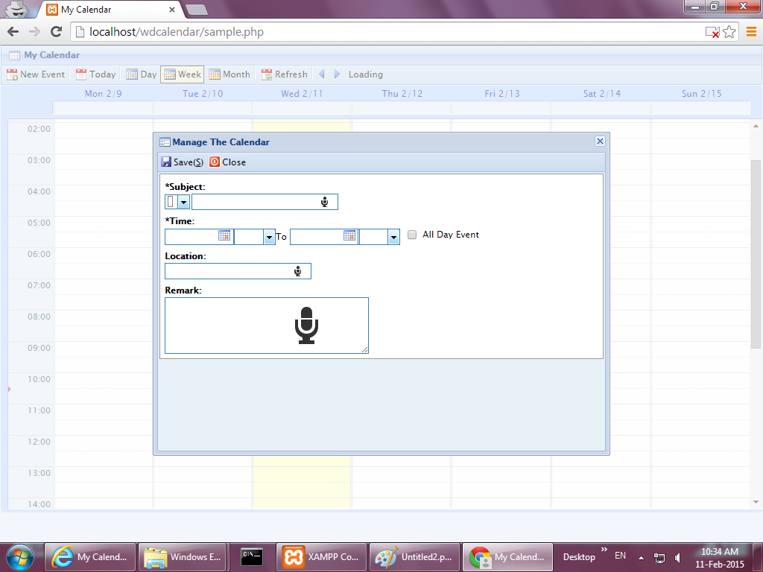

5

7

6

4

3

2

1

Figure 4.3 Editing details of an event

Notation: After clicking edit details, users will be directed to this page to edit details of events.

|  |  |  |  |
| --- | --- | --- | --- |
| 1 | Colour | Spinner | User can choose the colour of the title of an event |
| 2 | Title | Text Box | User can click the mic button to create the title through the voice input |
| 3 | Starting time | Spinner | User can choose the starting time and date |
| 4 | Ending time | Spinner | User can choose the ending time and date |
| 5 | All-Day | Check Box | User can click this check box to set an event be the all-day event |
| 6 | Location | Text Box | User can click the mic button to create the location of an event through the voice input |
| 7 | Remark | Text Box | User can click the mic button to create the special requirement of an event through the voice input |

**4.4 Day schedule**

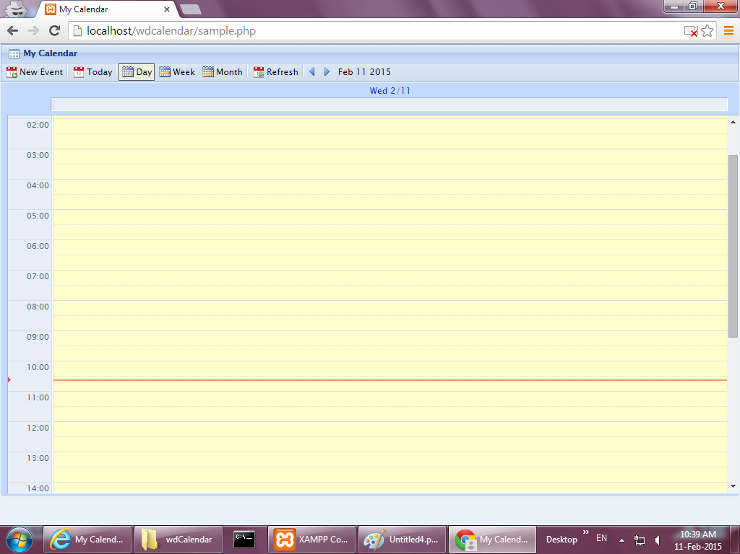

Figure 4.4 The day schedule

Notation: After clicking the day button, users will be directed to this page to show out events on that day

**4.5 Month schedule**

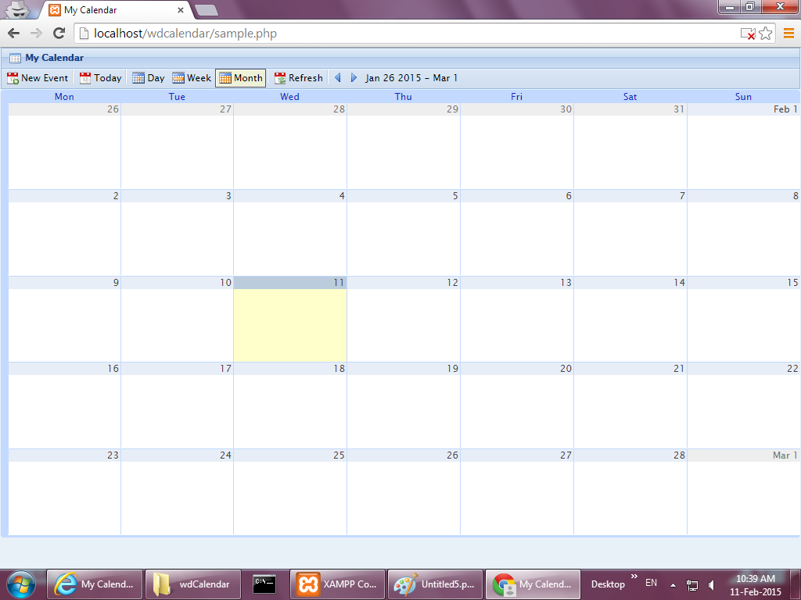

Figure 4.5 The calendar that shows a month

Notation: After clicking the month button, users will be directed to this page to see what events they have of a month